

***Test Site Data Analysis Code* Standard Operating Procedure**

*July 30th, 2023*

Lewis Mackay

**Revision History**

| **Rev** | **Date** | **Authors** |
| --- | --- | --- |
| V1.0 | *July 30th, 2023* | *Lewis Mackay* |
| V2.0 | *September 3rd, 2023* | *Lewis Mackay* |
| V3.0 | *August 28th, 2024* | *Lewis Mackay* |

**1 Introduction**

**2 SOP**

**Step 1:** **Download Necessary Files**

* **Go to folder:** 4.4 Propulsion/02 Test Site/’Data Analysis/Reports’/Data Analysis Code/V3.0 - 28-08-2024
* For a coldflow: Download **Coldflow_Report_Latex_Template.txt** and **Coldflow_Test_Site_Data_Analysis_Template.ipynb** from Google Drive
* For a hotfire: Download **Hotfire_Report_Latex_Template.txt** and **Hotfire_Test_Site_Data_Analysis_Template.ipynb** from Google Drive

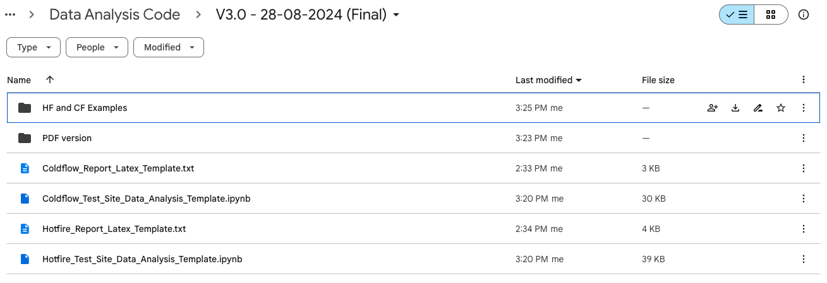

* Download the Hotfire/Coldflow data (**under 4.4 Propulsion/02 Test Site/Hotfire/Coldflow Data)**

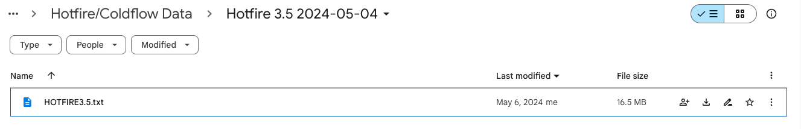

* Place downloaded files in the same folder

**Step 2:** **Jupyter Notebook**

* Open **Coldflow_Test_Site_Data_Analysis_Template.ipynb** or **Hotfire_Test_Site_Data_Analysis_Template.ipynb** in **Jupyter notebook** (alternatively, open the PDF versions and copy the code over). **Jupyter notebook** is my IDE of choice, but feel free to use whatever you like.
* Rename the notebook to indicate which hotfire/coldflow it is for.

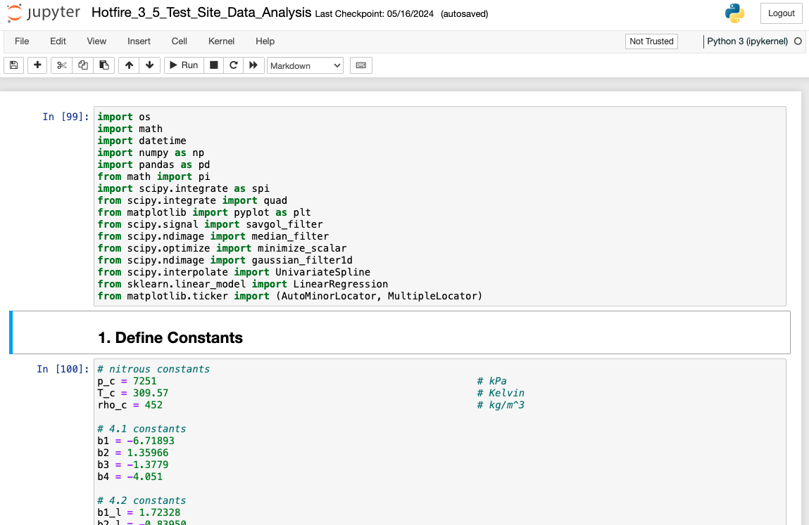

* The notebook is written in a way that takes you step-by-step through the data analysis.
  + I had originally written this to be **fully automated**, but ran into too many issues and inconsistencies. This method may seem daunting at first, but once you have done it once for a coldflow or hotfire, it will get easier.
  + You may run into some errors along the way. Feel free to contact **Lewis Mackay** if you run into anything you can’t figure out.
  + If you need an example to help you through it, See the [Coldflow 3.4 and Hotfire 3.5 Notebooks](https://drive.google.com/drive/u/0/folders/1mzg1hQlm2vMvAu7uSLPEinv37IPtZ9zB).
* **Follow the instructions** in the notebook, **one cell at a time**. Insert inputs (i.e. injector hole number, liquid start time etc…) when required. The notebook will take you through these sections:

**1. Define Constants**

**2. Define Functions**

**3. Determine Start and End Times**

**4. Extract Data**

**5. Mass Data Fitting and Mass Estimates**

**6. Calculate Important Parameters**

**7. Mass Error Propagation**

**8. Plots**

* Once you have gone through all the cells, the data analysis is complete.
* **Download the plots** that it generated and **record the important parameters** it printed out along the way. Upload them to the Drive.
* **Download the notebook** as an ipynb and pdf and upload to the Drive (very important if you ever need to go back and see the work that was done for a specific test).

**Step 3: LaTeX**

* Open **Coldflow_Report_Latex_Template.txt or Hotfire_Report_Latex_Template.txt**, select all and copy
* Open a LaTeX compiler, such as Overleaf, paste the contents and upload the plot images

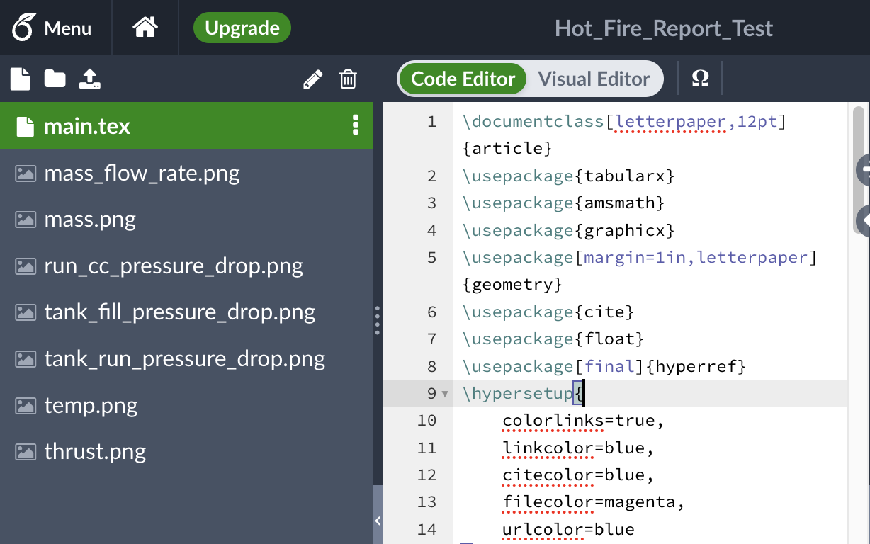

* Add necessary written information to LaTeX code (such as the important parameters calculated in the Jupyter Notebook) and recompile
* Download final report and upload to the drive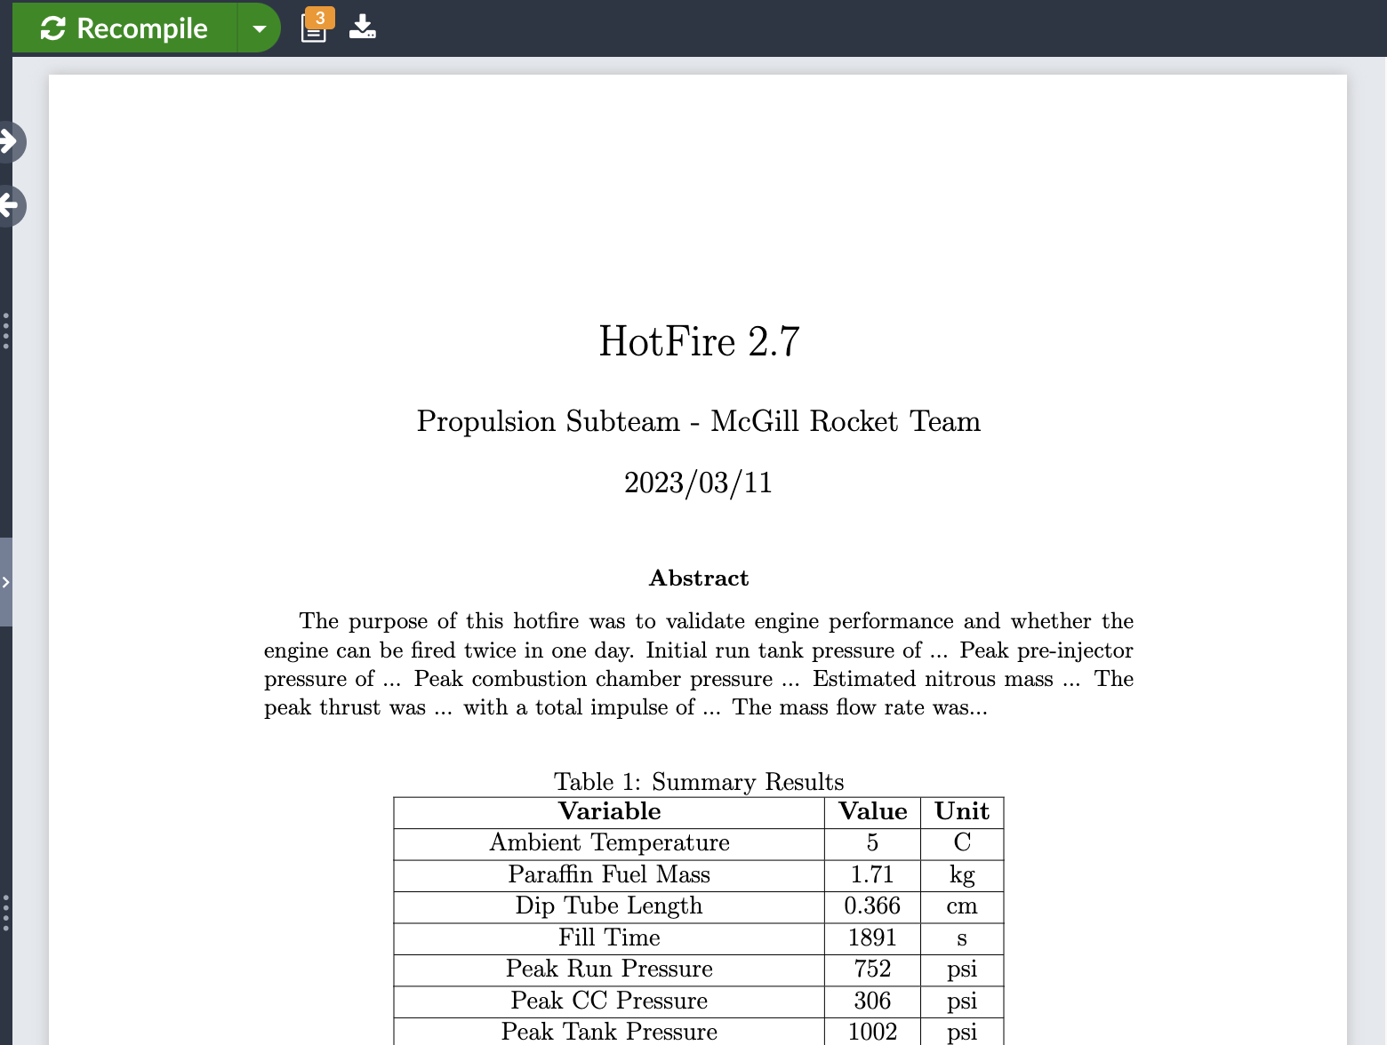
* By the end of this process, you should have a **Jupyter Notebook, Report** and all **plots** uploaded to the Drive.